**Heroes of Pymoli – Analysis**

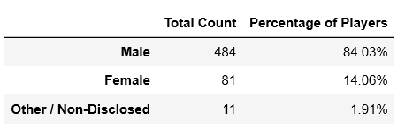

Without surprise, males are the dominant active players. Over the years playing many different style of games, I have seldomly come across female gamers.

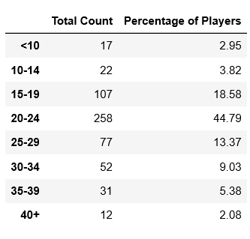

It’s not too far of a leap of faith to believe that the demographic between 20-24 is the highest peak age most probably male and because they have some disposable income & spare time to purchase games and enjoy the games.

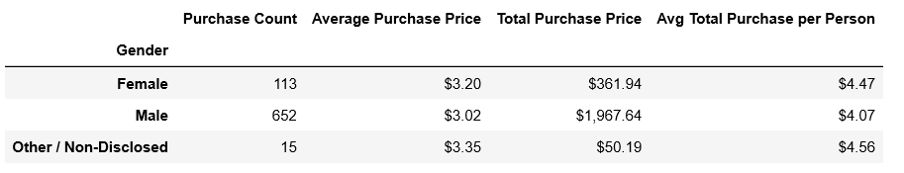  
  
It's interesting to see that females tend to purchase more expensive games and spend more per person. This could be because they are selecting higher value games as opposed to men would tend to purchase cheaper slasher games.

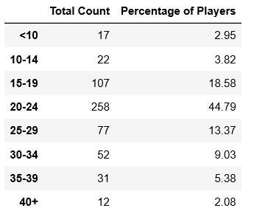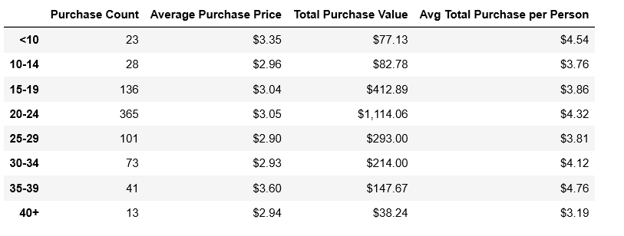  
  
Looking at the age demographics & purchasing analysis by age, it's interesting to see the drop off of purchase counts beyond 35+. This demographic most probably sees the most disposable income to purchase games but probably the least amount of time to enjoy them with other priorities taking precedence. This seems to be confirmed by this age group having the highest average purchase price and the highest average total per person.

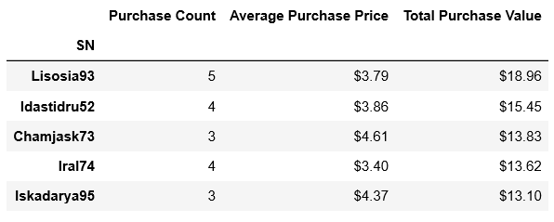

After doing a little look around in the CSV file, it's nice to see a female ( Chamjask73 ) in the top 5 spenders ( 20% ) which almost mirrors the 84% to 14% demographic. Most females purchased the Nirvana title, while most males purchased Final Critic. It would be interesting to see which genre of video games these are.

**Brian Labelle**